Page1

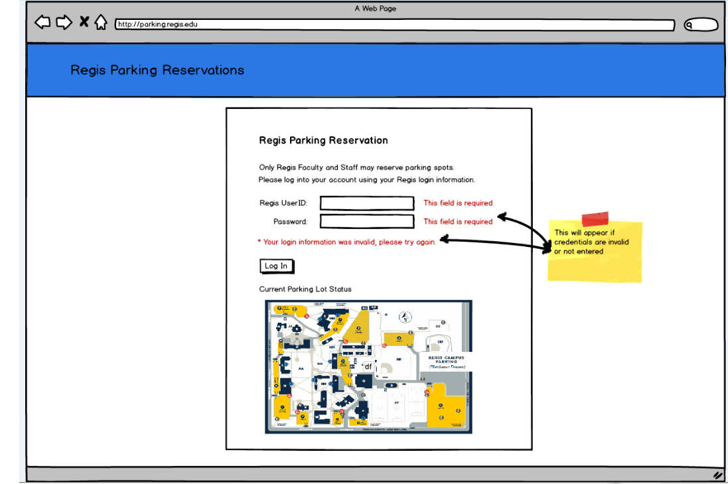

This page what we wanted is to add in this part the 72 hour rule, on the top paragraph. We also will like the map should show only the VIP lot. We do not believe it is necessary to have the rest of the map displayed. Since we are mostly concerned about the VIP lot.

Page 2

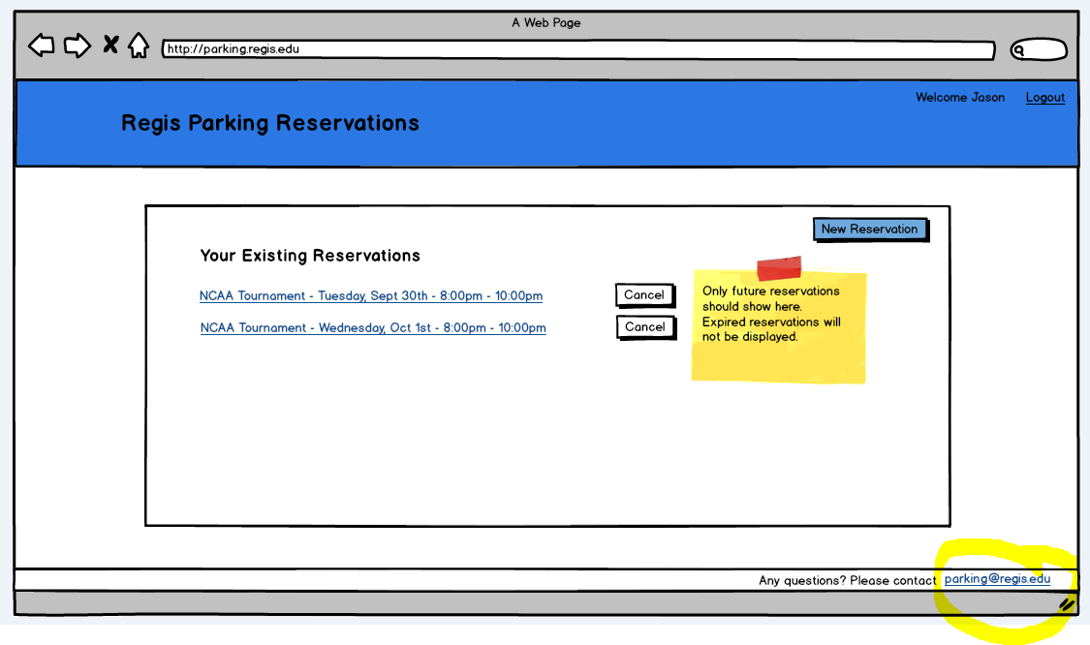

On this page we would only change the email address at the bottom to [ruparking@regis.edu](mailto:ruparking@regis.edu)

Page 3

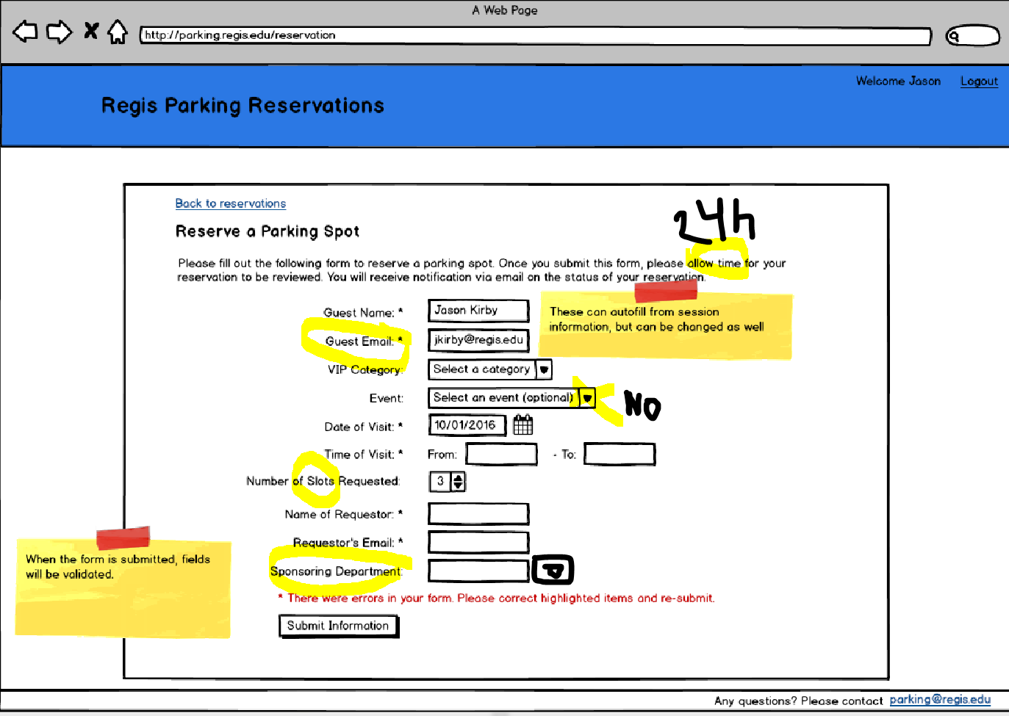

* We want on the top to say “24 hours time excluding weekends and holidays”
* Guest email we want it to be optional. The reason being most of the time the requester will print their passes for them.
* Event does not need a drop down. They can type in their event name.
* Instead of number of slots, we want them to say number of Spaces.
* Sponsorship department we want that to have a drop down menu.

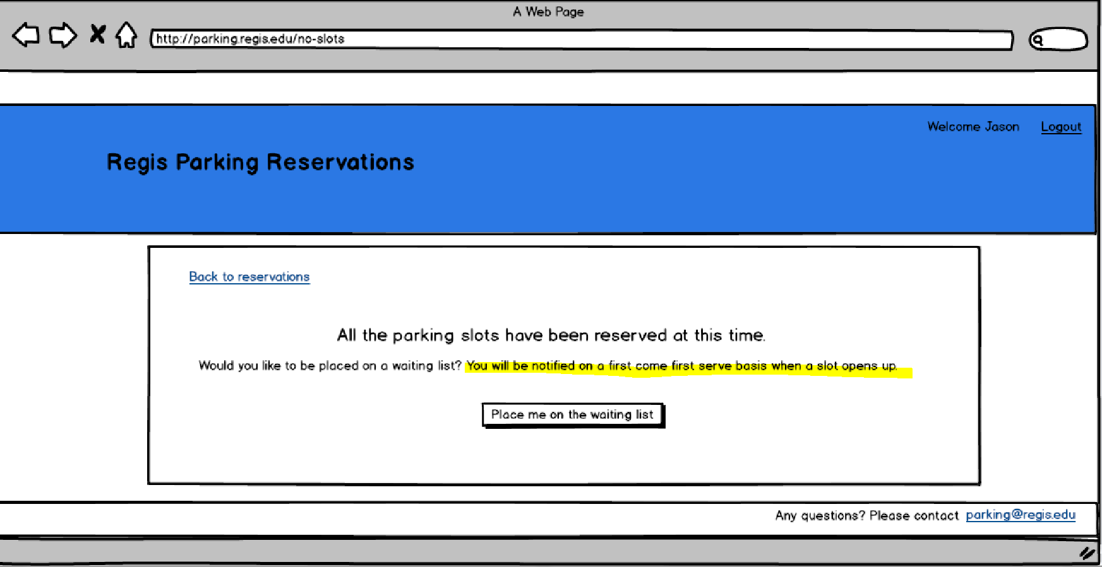

* For this part of page 3 we wanted it to say that they will contacted by us upon review. Because some cases are different than others.
* When they are placed in the waiting list, will it generate email to us?
* When they are placed on the waiting list, will they still be required to fill out the form above?

Page 4

We do not have any comments on that page.

Page 5

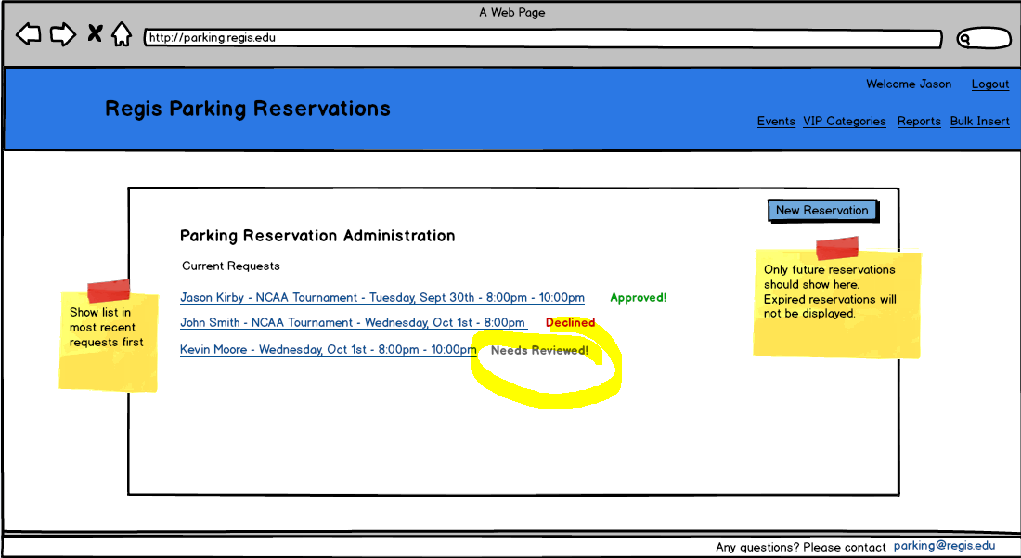

The only comment we have on this one is that instead need review it should say processing.

Page 6

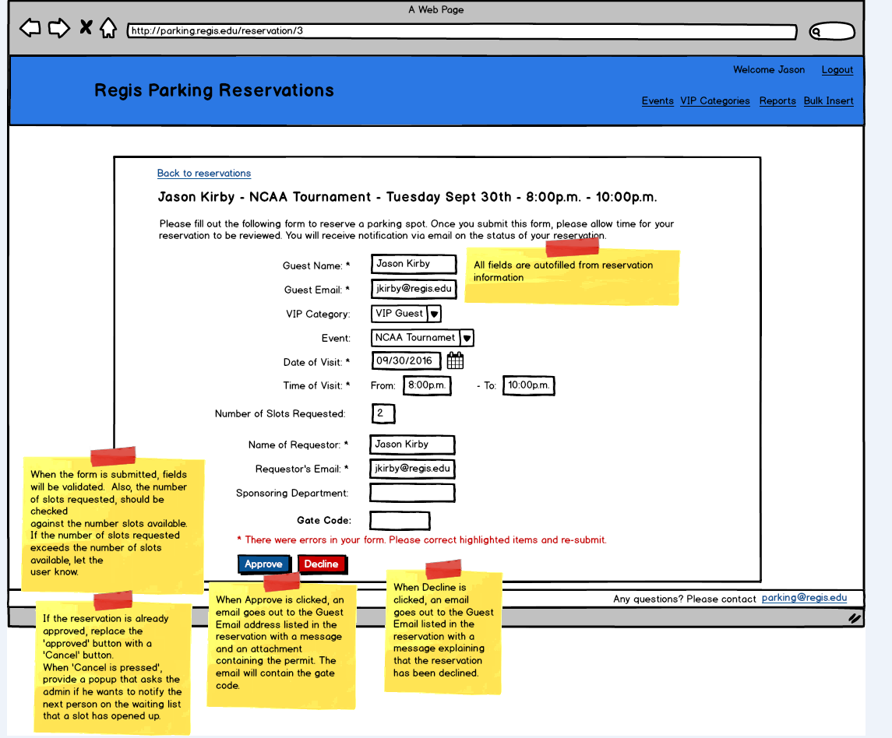

* We want to be notified when lot is full.
* Denied parking emails should not be sent to the guest, only to the requester.
* We were wondering about partial reservation, Will we have the ability to approve a partial reservation as an admin?
* Can an admin edit an event?

Page 7

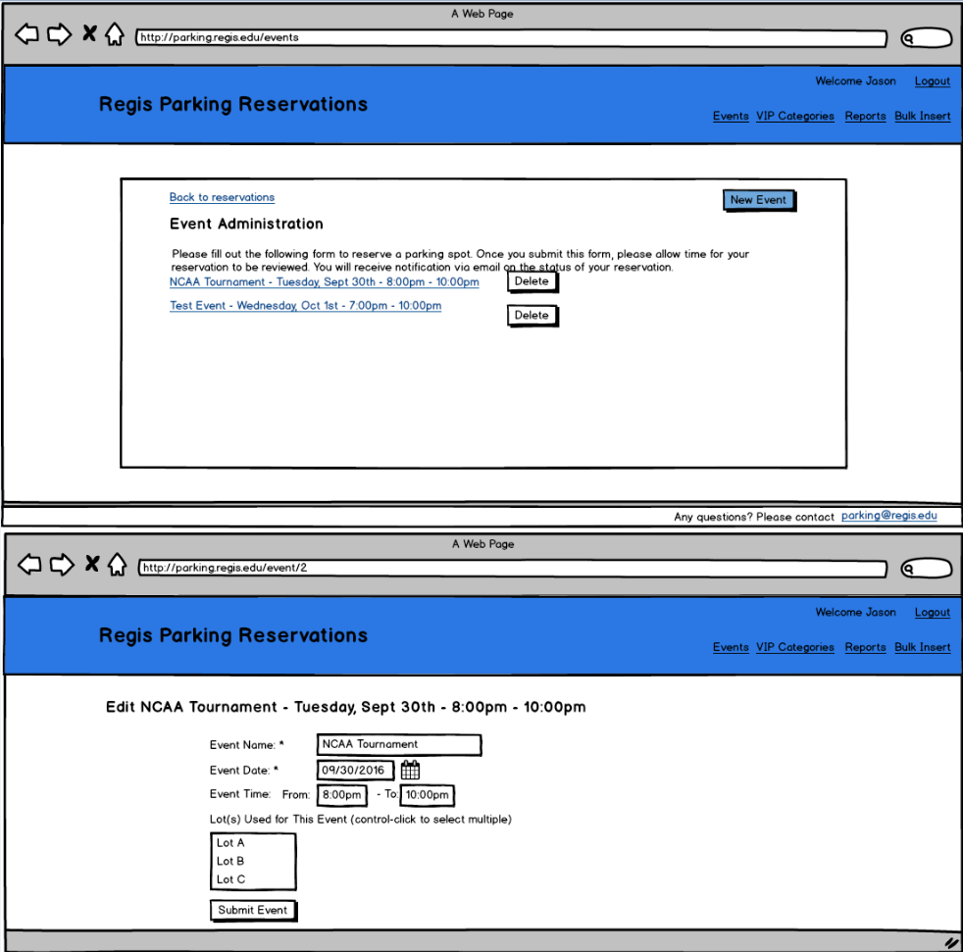

* Can a admin assign the lot?
* Can we only have two options? Any lot and VIP lot?
* Will customer be able to choose a lot? We do not want them to. We want to be able to assign those permits.
* IF we were to grant any lot permit, how will that affect the VIP counter?

The rest of the slides after that we were not sure what to make of them. I believe we need more explanation.

Some other concerns we have was:

* Can we update information if it changes? For example if we wanted to add or remove a department.
* Also I was wondering support after the project. How can we get support after this system is launched?
* Permits, can we include barcodes on the permits, or how are we going to track them?